CJFAS Article

Habitat Complexity and Phenotypic Variation: Stream and Reach-scale Thermal Heterogeneity Structures Diverse Spawning Portfolios in Interior Chinook Salmon
Thermal heterogeneity structures a diverse Chinook Salmon spawning portfolio across a stream network

Russell F. Thurow^{1†*} (ORCID iD: 0000-0002-1362-8599)
Bryan M. Maitland^{2†} (ORCID iD: 0000-0002-4491-5064)
Morgan M. Sparks² (ORCID iD: 0000-0003-0787-2218)
Daniel J. Isaak² (ORCID iD: 0000-0003-2963-1546)
John M. Buffington² (ORCID iD: 0000-0002-2513-5863)

¹US Forest Service, Rocky Mountain Research Station (Emeritus), Salmon, ID, USA 83467
²US Forest Service- Rocky Mountain Research Station, Boise, Idaho, USA 83702.
† Dual first authors

*Corresponding author (e-mail: russ.thurow@usda.gov)
Abstract
Pacific salmon exhibit diverse life histories and local adaptation shaped by spatiotemporal variation in biotic and abiotic conditions. This biocomplexity buffers populations against environmental variability and reduces risks of demographic failure. One key aspect of biocomplexity is spawning phenology, a reproductive attribute that generates population resilience in Pacific salmon. The environmental mechanisms structuring spawning phenology in salmonids are complex making it difficult to link to key environmental features. To this end, we analyzed 3,016 wild Chinook salmon (Oncorhynchus tshawytscha) redds georeferenced from 2002-2005 across eight tributaries to Idaho’s Middle Fork Salmon River and evaluated how stream- and reach-scale thermal conditions and spatial habitat variation influenced spawn timing. Linear mixed-effects models with stream-reach random intercepts and slopes explained most of the variation in observed salmon spawning dates (marginal R² = 0.599; conditional R² = 0.990). Spawn timing advanced nonlinearly with antecedent 90-day mean water temperature and plateaued at warmer sites. Stream and year effects were also significant, with spawning occurring progressively later through time. Importantly, reach-specific random slopes revealed pronounced heterogeneity in thermal sensitivity, suggesting that unmeasured local hydrologic and geomorphic processes mediate phenological responses to temperature. Together, these results demonstrate that fine-scale habitat heterogeneity, particularly thermal heterogeneity, structures diversity in this salmon phenological portfolio. Notably, we documented the persistence of diverse spawning phenology and sensitivity within this interior Chinook salmon population despite extremely low contemporary abundances and its “Threatened” status under the U.S. Endangered Species Act. Conserving diversity in spawn timing across heterogeneous habitats in dynamic environments may be critical for maintaining the adaptive capacity of Chinook salmon to a warming climate.
Keywords
Spawn timing, portfolio effect, biocomplexity, life history diversity, phenotypic plasticity, habitat heterogeneity, resilience
Introduction
Pacific Salmon populations exhibit extraordinary life history diversity, shaped by complex and heterogeneous environments across their range (Brannon et al. 2004). The enormous diversity of salmon life history traits (Waples et al. 2004) evolved in response to spatiotemporal variation in both biotic and abiotic conditions (Stearns 1976) and acts to reduce risks of demographic failure by buffering populations against environmental change and exploitation (Hilborn et al. 2003, Greene et al. 2009; Schindler et al. 2010; Beamish 2016). Chinook salmon (Oncorhynchus tshawytscha) display an especially diverse demographic portfolio characterized by a broad array of phenotypes, including variation in age and timing of seaward migration, duration of freshwater and marine residence, ocean distribution, age and season of spawning migration, and timing of spawning (Healey 1991).
Among these traits, spawning phenology has important ecological and evolutionary consequences. The timing of adult migration and spawning can shape reproductive isolation among temporally segregated groups and lead to fine-scale local adaptation (Manhard et al. 2017). While run timing (entry into freshwater) is often used to define populations segments (Brannon et al. 2004; Waples et al. 2004), here we focus on spawn timing (the date adults deposit fertilized eggs in gravel), as a fine-scale expression of phenotypic variation. Streams provide spatially heterogeneous natal habitats essential for salmon spawning and rearing (Jacobs et al. 2023). Time of spawning is determined by season of entry into freshwater, length and speed of river migration, and time spent in a pre-spawning stage (Ricker 1959). Salmon spawn timing is a key trait in population divergence because it reflects adaptation, strongly influences other traits, and augments spatial isolation of populations (Quinn et al. 2001). Spawn timing varies within and across salmon populations and has a well-documented genetic component (Ricker 1972; Quinn et al. 2002; Beulke et al. 2023). For example, high site fidelity and limited straying spatially segregates related individuals in proximate habitats leading to fine-scale genetic structuring (Neville et al. 2006). Spatial heterogeneity in habitat conditions likely promotes this diversity by selecting for locally adapted phenologies (Ruff et al. 2011).
Temperature strongly influences salmonid spawn timing (Hendenon 1963; Morrison and Smith 1986; Beechie et al. 2008). Because embryonic development rates are mechanistically driven by ambient temperature (Sparks et al. 2025), salmon tend to spawn at times that ultimately synchronize fry emergence with conditions that optimize offspring growth and development (Quinn 2018; though see Sparks et al. 2019). Several studies have linked site-specific thermal regimes to observed variation in spawning phenology (Sheridan 1962; Burger et al. 1985; Heggberget 1988; Lisi et al. 2013). However, although the importance of temperature as a determinant of spawn timing is well established, the underlying landscape features that may drive thermal variation (i.e., physiography, geomorphology, and hydrology), are poorly understood (Montgomery 1999; O’Sullivan et al. 2019). Geomorphic attributes including slope, elevation, confinement, and groundwater connectivity can shape reach-scale thermal regimes, thereby constraining or enabling different spawning strategies (Beechie et al. 2006, 2008; Jonsson and Jonsson 2011). Lisi et al. (2013), for example, demonstrated that variation in watershed slope, elevation, and lake area explained a large proportion of summer stream temperature and timing of Sockeye salmon (Oncorhynchus nerka) spawning in Alaskan streams, suggesting that geomorphology may play an indirect but important role in structuring phenological diversity across stream networks.
The Middle Fork Salmon River (Middle Fork) supports one of the most intensively monitored wild Chinook salmon populations in the Columbia River Basin. Long-term redd surveys by state, federal, and tribal agencies provide a uniquely rich dataset for examining environmental drivers of spawning phenology. The Middle Fork supports wild, indigenous Chinook salmon populations unaltered by direct hatchery supplementation (Thurow et al. 2020) and the watershed is managed as a designated wild anadromous fish sanctuary (IDFG 2019). Minimal anthropogenic effects and a geographic size that facilitates natural processes (i.e., wildfire, floods, debris flows, and snow avalanches) ensure generation and maintenance of diverse environmental conditions (Isaak et al. 2003; Thurow 2015). These natural processes function relatively unimpeded by humans because most of the watershed lies within designated Wilderness. As a result, natal salmon habitats remain diverse, high quality, and connected, and exotic fishes are relatively uncommon (Thurow 2000; Isaak and Thurow 2006; Thurow 2015).
Understanding the nature and causes of phenological diversity is of critical importance to recovery of Pacific salmon (Taylor 1991; Waples et al. 2004). Phenology is far more difficult to measure than temperature so the relationship between fine-scale thermal heterogeneity and timing of salmon spawning is poorly understood (Deacy et al. 2019). We leveraged the Middle Fork’s unique characteristics and robust dataset to examine how variation in stream temperature and habitat attributes influence Chinook salmon spawn timing across multiple years in several tributaries. Characterizing variation in natural processes within stream networks and understanding how spatial and temporal variability in physical processes and Pacific salmon interact are critical, both for establishing recovery targets (Bisson et al. 2009), and for evaluating population persistence under changing environmental conditions (Craig et al. 2017, Isaak et al. 2018). Our objectives were to: 1) describe stream reach-scale physical attributes and Chinook salmon spawning phenology from 2002 to 2005, 2) summarize variation in spawn timing across four years in eight streams, and 3) fit a series of linear mixed-effects models to identify associations between environmental covariates and spawn timing. Our goal is explicitly descriptive — to characterize the structure and environmental determinants of spawn timing variation within this system at fine spatial resolution — rather than to develop a transferable predictive framework. The reach-level detail afforded by this approach provides a foundation for future comparative work across broader geographic scales.

Methods
Study Area
The Middle Fork drains ~7,330 km² of Central Idaho, predominantly within the Frank Church River of No Return Wilderness, and is one of eight original National Wild and Scenic Rivers designated in 1968 (Figure 1; NWSRS 2016). From its headwaters the Middle Fork flows 171 km before joining the Salmon River near Salmon, Idaho (USFS 1998; Minshall et al. 1981; Thurow et al. 2020). Approximately 800 km of mainstem and tributary habitat are accessible to Chinook salmon (Mallet 1974; Thurow 1985). Detailed study area information can be found in Minshall et al. (1981); Thurow (2000); Servheen et al. (2001); and Thurow et al. (2020).
Adult Chinook salmon migrate from the Pacific Ocean up the Columbia and Snake rivers to spawn in the Middle Fork, typically arriving in early summer and spawning from late July to mid-September. Salmon in this system express a stream-type life history, with most juveniles rearing for one year in freshwater before outmigration (Healey 1991). However, fish exhibit multiple freshwater (age 0-2) and saltwater (1-5) ages, in addition to non-migrating precocial males (Gebhards 1960; James et al. 1998; Copeland and Venditti 2009). Observations suggest that early-arriving adults tend to spawn at higher elevations and later arrivals spawn progressively lower in the basin (Fulton 1968; Gebhards 1959; IDFG 1992; Parkhurst 1950).
Despite the Middle Fork’s high quality natal habitat, its Chinook salmon are at high risk of extirpation (NOAA 2017). These fish belong to the Snake River spring/summer Chinook salmon Evolutionarily Significant Unit (ESU), listed as “Threatened” under the Endangered Species Act (ESA; NMFS 1992). Current salmon populations average 1-3% of the abundances that annually returned into the mid-1960s (Thurow et al. 2020). Altered migration corridors are considered a proximate cause of salmon declines in the upper Snake River basin in recent decades (Jacobs et al. 2022). NOAA (2022) stated that the centerpiece recovery action is restoring more normalized reach-scale hydrology and hydraulics, and thus river
conditions and function in the lower Snake River and emphasized the urgency of actions is accentuated by climate change.

Reach selection, Chinook salmon redd counts, and spawn timing
From 2001-2005, we selected study reaches in six major drainages (Big, Bear Valley, Camas, Loon, Marsh, and Sulphur creeks) and included Beaver Creek (tributary to Marsh Creek) and Elk Creek (tributary to Bear Valley Creek) to total eight salmon spawning tributaries that encompass a range of variation in elevation, stream size, and spawn timing. To support collaboration and improve efficiency, some study reaches overlapped with existing index reaches monitored annually by the Idaho Department of Fish and Game (IDFG), the Nez Perce Tribe, Shoshone Bannock Tribe, or the U.S. Forest Service (see Thurow et al. 2020 for index reach methods and locations). Spawning occurs across a broad elevation range, from <920 m in the lower mainstem to >2000 m in tributary headwaters. After selecting reaches, surveyors designated and marked subsections where redds would be identified and georeferenced.
Redd surveyors intensively monitored Chinook salmon spawning from the onset of redd construction through the completion of spawning. From late July through mid-September, trained observers walked stream banks within each study reach on 3-4-day intervals and searched for newly constructed redds. Surveyors began searching for redds before the onset of spawning and georeferenced redd locations with GPS units. To avoid commission errors during the initial survey, surveyors recorded all prior year redds or redd-like streambed features that might have been confused with newly constructed redds. Based on our prior observations in the Salmon River basin, female Chinook salmon typically remain on excavated redds for 3-5 days. Consequently, we assumed our 3-5-day survey interval maximized the likelihood of detecting all redds soon after their construction.
Based on our survey intervals, we inferred spawn timing from the first date a redd was fully constructed. Redd locations were spatially joined to stream reaches in the NHDPlus dataset (Moore et al. 2019) and assigned a common identifier (COMID). This identifier was used to link each redd with environmental covariates measured in or derived from the corresponding stream reach (i.e., COMID). We excluded data from 2001, and from Knapp and Cape Horn creeks (Marsh Creek tributaries) because of inconsistent sampling. The final dataset contained 3,016 georeferenced redds (i.e., inferred spawn date) across 104 stream reaches (i.e., COMIDs), nested within the eight spawning tributaries listed above, and spanning four years.

Covariates
Covariates were selected based on ecological relevance, full coverage across the study area, and low collinearity (Appendix A1, Section 1.2). Elevation and slope were obtained from NHDPlus (McKay et al. 2012). We indexed thermal conditions using modeled daily stream temperatures at the COMID level from Siegel et al. (2023) after confirming strong agreement with empirical temperature data measured in Idaho (Figure A1.7). Stream discharge data were drawn from a single USGS gage (13309220) near the basin outlet. For each redd, we calculated sequential time-windowed summaries of temperature and flow; i.e., 30-, 60-, and 90-day averages prior to, during, and following the inferred spawn date.
Initially, we established our modeling framework using exploratory data to evaluate variation in spawn timing across years and streams, examine bivariate relationships between spawn date and continuous covariates, and assess pairwise correlations among predictors (Appendix A2). Based on these results, we retained 90-day antecedent temperature (temp_90; hereafter “temperature”) as the sole thermal covariate; shorter windows (30- and 60-day) were highly collinear with temperature and showed weaker bivariate relationships with spawn date. Post-spawn and fixed-date summaries were weakly associated with spawn timing excluded from further consideration. Stream slope showed no meaningful relationship with spawn date and was excluded. Although 90-day antecedent streamflow was initially considered, it was derived from a single downstream USGS gauge and therefore lacked spatial resolution across the study reaches; moreover, because year-to-year variation in flow dominated its signal, it was strongly collinear with the year fixed effect (VIF > 1000 in models including both), making independent inference impossible. We therefore excluded 90-day antecedent streamflow to avoid misleading attribution of year-level variation to reach-scale flow conditions.

Data analysis
We used linear mixed-effects models to evaluate environmental predictors of Chinook salmon spawn timing, with redd observation day-of-year as the response variable. Continuous covariates were scaled (mean = 0, SD = 1) to aid convergence and model interpretation. All models included a random intercept for `COMID` to account for repeated measures across stream reaches. Based on residual diagnostics from initial models and biological expectations of nonlinear thermal responses—including a potential plateau at warm temperatures—we evaluated multiple functional forms for the temperature effects, including quadratic and natural spline terms.
We fit 31 additive models representing all combinations of fixed effects (temperature, stream identify, year, reach slope, and mean elevation; Appendix A3.1). Models additionally including elevation (m26, m31) had the lowest AIC among candidate models and predicted later spawning at higher elevations in a multivariate context. However, these models were excluded from further consideration because moderate collinearity between elevation and stream identity (VIF ≈ 6.5) introduced instability in the fixed effect estimates, and because the within-stream elevation signal that elevation as a fixed effect was attempting to capture is expressed more flexibly through the reach-level random effects structure of the final model. Model selection therefore identified the additive model including quadratic temperature, stream, and year (m16) as the most interpretable and parsimonious base model, with nearly identical predictive accuracy and conditional R² compared to m26 (Appendix A3.1). We then assessed whether temperature effects varied across stream reaches by extending m16 with COMID-specific random slopes for temperature and compared models fit with restricted maximum likelihood (REML). Given the substantial improvement with random slopes (ΔAIC = 510), we next evaluated whether the quadratic temperature formulation adequately captured the nonlinear temperature–spawn timing relationship. We compared the quadratic random slope model to models using natural spline terms with three and four degrees of freedom, fit using maximum likelihood. A natural spline with three degrees of freedom substantially outperformed the quadratic (ΔAIC = 139) with improved residual behavior, while the spline with four degrees produced biologically implausible predictions at warm temperature extremes indicative of overfitting and was excluded (Appendix A3.4). We therefore selected the natural spline with three degrees of freedom as the temperature functional form. Finally, we evaluated whether fixed-effect interactions between temperature and either stream or year improved model performance. The temperature × stream interaction produced severely implausible predictions for data-sparse streams (spline extrapolation outside observed temperature ranges), and the temperature × year interaction, while showing a ΔAIC of 1482, appeared to capitalize on year-specific data ranges rather than a stable biological effect (Appendix A3.5). Both interaction terms were therefore excluded. The final model was refit with REML for parameter estimation, diagnostics, and interpretation. Model selection was based on AIC, and model performance was evaluated using marginal and conditional R², RMSE, and intraclass correlation coefficients (ICC).

Results
Spawn timing variation in space and time
Across all streams and years, Chinook salmon spawning exhibited a broadly unimodal distribution, with most activity concentrated between mid-August and early September (Figure 2A). The global mean spawn date was day 240 (August 28th), although year-specific means varied by nearly three weeks (Figure 2A). Stream-level spawning distributions revealed additional spatial structure (Figure 2B), with some streams (e.g., Bear Valley and Beaver creeks) exhibiting narrower peaks, while others (e.g., Big and Camas creeks) displayed broader or later distributions. Year effects were also evident (Figure 2C), with 2005 skewed later than preceding years.
When examined jointly by stream and year, density curves illustrated that each stream expressed a characteristic spawn timing “signature”; although the strength and consistency of the signature varied (Figures A1.3-1.4). Some streams (e.g., Beaver and Marsh creeks) displayed sharp, highly synchronous peaks, whereas others (e.g., Big, Camas, and Elk creeks) exhibited broader, more heterogeneous distributions. These stream-level differences were nested within year effects, reinforcing the combined influence of space and time on diverse spawning phenology.
The cumulative proportion of redds (Figure 3) provided an intuitive view of the pace and duration of spawning. Streams such as Marsh and Sulphur creeks exhibited rapid increases, suggesting short, concentrated spawning intervals. In contrast, Big and Camas creeks displayed more gradual redd accumulations, indicative of extended spawning seasons. Interannual variability was also evident, with some streams shifting substantially across years. Together, these patterns highlight the pronounced spatial and temporal heterogeneity in Chinook salmon spawn timing across the Middle Fork watershed.

Model comparison
We used AIC-based model selection to identify parsimonious models explaining spatial and temporal variation in spawn timing. Among the 31 additive model tested, stream identity, interannual variation, and nonlinear temperature responses were the strongest predictors of Chinook salmon spawn timing (Table 1; Appendix A3.1). Models additionally including elevation (m26, m31) had the lowest AIC among the candidate models and predicted later spawning at higher elevations in a multivariate context. However, elevation was excluded for two reasons. First, the moderate collinearity between elevation and stream identity (VIF ≈ 6.5) introduced instability in the fixed effects estimate. Second, and more fundamentally, the within-stream elevation signal that elevation as a fixed effect was attempting to capture is expressed more flexibly and with greater precision through the reach-level random effects structure of the final model. Model m16 had nearly identical predictive accuracy (RMSE = 2.02 days) and conditional R² (0.980) compared to m26, despite a modest reduction in marginal R² (0.729 vs. 0.785). Extending m16 to include COMID-specific random slopes for temperature substantially improved model fit (ΔAIC = 510), reduced prediction error from 2.02 to 1.78 days, and slightly increased conditional R², confirming that temperature effects vary meaningfully among stream reaches (Table 1).
We next evaluated the functional form of the temperature effect within the random slope structure. Residual diagnostics for the quadratic random slope model revealed a systematic trend in residuals across the temperature gradient — overpredicting spawn timing at cold sites and underpredicting at warm sites — suggesting the quadratic term did not fully capture the nonlinear relationship (Appendix A3.3). A natural spline with three degrees of freedom substantially outperformed the quadratic formulation (ΔAIC = 139), with lower RMSE (1.72 vs. 1.78 days) and markedly flatter residuals across the temperature gradient (Appendix A3.4). A natural spline with four degrees of freedom showed further AIC improvement but produced biologically implausible predictions — spawn timing declining sharply above ~13°C — and was excluded (Appendix A3.4). The natural spline with three degrees of freedom was therefore selected as the temperature functional form.
Finally, we assessed whether interactions between temperature and either stream or year provided additional explanatory power beyond that captured by random slopes. The temperature × stream interaction produced implausible predictions for data-sparse streams (particularly Beaver Creek, where the spline diverged outside its observed temperature range), and the temperature × year interaction, while yielding a ΔAIC improvement of 1482, likely overfitted year-specific data ranges rather than capturing a stable biological effect — marginal R² and RMSE improved only modestly despite the large AIC gain (Appendix A3.5). Both interactions were excluded. These results led us to retain the natural spline random slope model without interactions as our final model.

Final model fit and diagnostics
Model fit for the final model was strong: marginal R² (fixed effects only) was 0.599, while conditional R² (fixed + random effects) was 0.990 (Table 2), with RMSE of 1.71 days. The gap between marginal and conditional R² reflects the predominance of reach-level random effects—particularly random slopes—in explaining spawn timing variation. The high ICC (0.98) confirms that spawn timing is strongly clustered within stream reaches — redds from the same COMID are far more similar to each other than to redds from different COMIDs, reflecting persistent reach-level habitat signatures that structure timing across years.
Model diagnostics indicated strong overall performance (Figure A4.1). The posterior predictive check showed excellent agreement between observed and model-predicted distributions of spawn timing. Collinearity was low, with VIFs for all fixed effects below 2. Residual plots revealed mild heteroscedasticity with slight funneling at lower values, likely reflecting skew in early spawn dates rather than model misspecification. The normality Q-Q plot showed moderate tail departures, indicating the Gaussian error assumption is imperfect but sufficient for inference. Random effect Q-Q plots for both intercepts and slopes tracked the diagonal with modest tail departures. DHARMa simulated residual diagnostics flagged several omnibus tests as significant (KS test p ≈ 0, dispersion p = 0.004, outlier p = 1 × 10⁻⁵); with n = 3,016 observations, however, DHARMa's tests readily detect minor deviations that carry little practical inferential consequence.

Population-level effects
We estimated marginal mean spawn timing at each factor level and averaged it over the random effects, to provide an overall estimate of the effect in the population. We observed significant differences in spawn timing between many stream pairs (Figure 4A; Table A4.3), particularly in Loon Creek (later spawning) compared to Sulphur Creek (earlier spawning). For example, fish in Loon Creek spawned significantly later compared to fish in Bear Valley, Camas, or Elk creeks, while Sulphur Creek exhibited significantly earlier spawn timing than all other streams except Elk Creek.
There was a clear trend toward later spawning over the four-year period (Figure 4B; Table A4.4). Spawning in 2005 occurred significantly later than in all previous years. Although differences between 2002 and 2003 were not statistically significant, later years (2004 and especially 2005) were associated with progressively later mean spawn timing.
Stream-specific predictions revealed a consistent pattern: spawn timing increased nonlinearly with 90-day mean antecedent stream temperature and leveled off at high temperatures (Figure 5). Stream-to-stream variation in predicted timing reflects both fixed stream effects and COMID-specific random intercepts and slopes. Year-specific predictions similarly exhibited consistent thermal responses across years, with modest variation in average spawn timing because of year effects.

Group-level effects (COMID deviations from population effects)
Random intercepts and slopes varied considerably among COMIDs, with substantial spread both within and between streams (Figure 6A, 6B). Random effects represent reach-level deviations in baseline spawn timing after accounting for fixed effects: a positive intercept indicates a reach where salmon tended to spawn later than expected given temperature, stream identity, and year; a negative intercept indicates earlier-than-expected spawning. Random slopes represent deviations in thermal sensitivity: steeper slopes indicate stronger temperature dependence, shallower slopes reflect weaker or buffered responses. Among-reach variance was substantial for both baseline timing (τ₀₀ = 128.20) and thermal sensitivity (τ₁₁ = 33.44), and the pattern of variation differed among streams. The intercept-slope correlation was strongly negative (ρ₀₁ = −0.83; Figure 6C), indicating that reaches with earlier baseline spawn timing exhibited strongly positive thermal responsiveness. In contrast, later-spawning reaches exhibited shallower or negative thermal responsiveness.

Figure 6D translates these random effect patterns into predicted temperature–spawn timing relationships for individual COMIDs, illustrating how the combination of varying intercepts and slopes generates a diverse family of reach-specific trajectories around the population mean. The strength and shape of the temperature-spawn timing response varies substantially among reaches, likely reflecting fine-scale differences in hydrology, geomorphology, and local thermal buffering capacity.

Discussion
We analyzed a highly spatially and temporally resolved dataset 3,016 Chinook salmon redds across eight streams and four years to investigate Chinook salmon phenotypic diversity and the environmental determinants of spawn timing. A natural spline formulation of antecedent 90-day mean water temperature—capturing a strong nonlinear increase in spawn timing that leveled off at warm sites—emerged as the dominant population-level predictor. Our final linear mixed-effects models explained 60% of variance attributable to fixed effects and 99% when reach-level random effects were included (marginal R² = 0.599; conditional R² = 0.990), with RMSE of 1.71 days — performance that compares favorably to similar studies (e.g., Lisi et al. 2013). The high ICC (0.98) underscores that reach identity is the single strongest organizing principle of spawn timing variation: individual reaches have characteristic timing signatures that persist across years, shaped by fixed and dynamic habitat attributes, local thermal regimes, and unmeasured hydrologic and geomorphic processes. Reach-specific random slopes revealed pronounced heterogeneity in thermal sensitivity, with a strong negative intercept-slope correlation (ρ₀₁ = −0.83) indicating that earlier-spawning reaches are more thermally responsive than later-spawning ones. Together, these results demonstrate that fine-scale habitat heterogeneity, particularly thermal heterogeneity mediated by local geomorphic and hydrologic processes—structures diverse Chinook salmon spatial and temporal spawning portfolios at both stream and reach scales.

Multiple studies have proposed a causal relation between the thermal regime during incubation and the time of adult spawning (Heggberget 1988; Brannon et al. 2005). As Brannon stated, “The controlling mechanism in spawn timing, however, is the timing of fry emergence, which translates into fitness.” Our analysis of different pre- and post- spawn metrics, however, does not support the proposed incubation-spawn timing relationship. We suggest that habitat availability and survival during spawning may also be important selective forces in the pre-spawn and spawn life stages. We also found temperature at individual spawning sites to be highly correlated throughout the year, suggesting a latent effect whereby site-level thermal regime is a persistent signature rather than a proximate cue operating through a specific seasonal window. Our understanding of the mechanisms controlling salmon spawn timing would benefit from further evaluation of the incubation life stage; one promising approach would be to model developmental phenology using Middle Fork temperature data—or other locations with strong spawning records—with newly developed methods for predicting phenology in wild populations (Sparks et al. 2019; 2025).
The nonlinear thermal responses and reach-specific random slopes highlight diverse thermal sensitivities of salmon spawning across the landscape. The strong negative intercept-slope correlation indicates that fish spawning earlier in higher-elevation reaches tend to show stronger temperature dependence. Biologically, this pattern suggests that early-spawning reaches exhibit more dynamic responses to temperature —adjusting spawn timing more closely to thermal cues and exhibiting broader variation in response to temperature change. In contrast, later-spawning reaches may be constrained by other factors such as photoperiod, migration fatigue, or compressed spawning windows, resulting in diminished thermal responsiveness, or may be operating near thermal ceilings that further prevent phenological advancement regardless of temperature signal. These contrasting patterns across emphasize that even within a single watershed, thermal sensitivity is not uniform but varies with habitat context in ecologically meaningful ways.
The topographic variables we tested — discharge, elevation, and slope — were weak predictors of spawn timing and introduced effects that were rendered unstable by collinearity with temperature and confounding with stream identity. Elevation warrants particular attention. In raw data, higher-elevation reaches spawn earlier — a relationship largely mediated by the strong negative correlation between elevation and temperature. However, in multivariate models that include temperature, the residual effect of elevation on spawn timing is positive: once thermal variation is accounted for, higher-elevation reaches tend to spawn later, suggesting that elevation captures an additional, as-yet unidentified pathway influencing spawn timing that is independent of the thermal signal already in the model. Spatial Stream Network models (Isaak et al. 2013) may offer a more rigorous framework for disentangling topographic and geomorphic influences on reach-level processes across broader geographic scales, where elevation gradients are more consistently expressed across systems.

Abundance, phenotypic diversity, and the limits of our sample

A central question motivating this work is whether the spawning portfolio we documented represents the full phenotypic diversity this population can express, or whether it reflects a contracted diversity associated with historically low abundances. We hypothesize the latter. Between 1995 and 2022, adult salmon returns averaged 1–3% of mid-1960s abundances (Thurow et al. 2020), and from 2023–2025 that figure has not improved; index redd counts from 2023–2025 suggest cumulative returns remained at approximately 1–2% of mid-1960s abundances (M. Donovan, IDFG, personal communication). The population we sampled was far below the carrying capacity of available spawning habitat, leaving many suitable areas unoccupied.
Although few studies have directly examined the relationship between adult salmon returns and phenotypic diversity, there is evidence that broader spawning diversity is expressed when more adults return. Davis (2015) examined the duration of salmon availability as a food source across three orders of magnitude in spawner abundances and found that spawning salmon were available to predators up to 2.5 times longer at the largest compared to the smallest abundances—a result consistent with greater phenotypic diversity, specifically broader variation in spawn duration, at higher escapements. Our own data from the Middle Fork offer a suggestive parallel: in 2003, when adult returns were the largest recorded since the 1980s, five of 33 mainstem redds were constructed nearly 10 days later than the latest redds in prior years (24–26 September versus 15–17 September), and spawners were observed using larger cobble substrate in reaches not used in other years (Thurow et al. 2020). Buffington et al. (In review) confirmed this pattern spatially, predicting that as escapements increased, salmon expanded the range of substrate used and occupied more stream reaches within the Middle Fork.
Historical records are consistent with the pattern as well, though they must be interpreted cautiously. In the late nineteenth century, when an estimated 8–10 million Chinook salmon annually entered the Columbia River (Lichatowich and Mobrand 1995), spawn timing in the Middle Fork system appears to have extended considerably later into the fall than is observed today. Captain Bernard’s forces traveled down Big Creek in July 1879 and observed what appears to have been active spawning near Cabin Creek—weeks earlier than the contemporary August onset for summer-run fish in that reach (Minshall 2014). In
adjacent South Fork Salmon River drainages, diary entries and oral histories from the 1890s–1930s describe salmon spawning in November, a phenology with no known contemporary counterpart (Burns 1992). We cannot rule out other explanations for these observations, but taken together with Davis (2015) and our own 2003 data, they are consistent with the hypothesis that the Middle Fork's current spawning portfolio, though already remarkably diverse, represents a contracted expression of the phenotypic range possible at higher abundances. Whether currently at-risk populations retain the genetic capacity to re-express absent life history types as abundances recover is an important empirical question — one that dam removal experiments like the Elwha (Pess et al. 2024; Peters et al. 2025) are beginning to address elsewhere.

Management and conservation implications
The Middle Fork represents a uniquely intact reference system for studying phenological processes that operate with minimal anthropogenic alteration. Its Chinook salmon and steelhead (Oncorhynchus mykiss) populations are wild and indigenous, unaltered by hatchery supplementation (Thurow et al. 2000). Natural disturbances—wildfire, floods, debris flows—continuously generate and maintain habitat diversity across the 7,330 km² basin (Isaak et al. 2003, Thurow 2015). The 650 km of accessible tributaries and 170 km of accessible mainstem (Mallet 1974; Thurow 1985) provide a physical template for the expression of diverse phenotypes that is rare in the Columbia River basin; stream-type Chinook populations of this character persist in only 4% of the potential historical range (Thurow et al. 2000).
Our results reinforce the conservation argument for protecting the habitat heterogeneity that produces phenotypic diversity. Diverse temperature regimes within and among streams give rise to among-population life history diversity (Cordoleani et al. 2021), and the portfolio effect — wherein asynchronous spawning across spatially variable habitats buffers populations against environmental stochasticity — is considered essential for maintaining salmon stock abundance and resilience (Hilborn et al. 2003; Schindler et al. 2010; Hugentobler et al. 2024). The consumer dimension of this portfolio is also ecologically significant: variation in spawn timing across thermally heterogeneous reaches enables mobile consumers — bears, eagles, otters — to locate profitable foraging opportunities sequentially across the watershed rather than competing at a single synchronous pulse (Schindler et al. 2013). When spawning is spatially asynchronous at fine scales, consumers do not need to travel far to exploit temporal variation in resource availability (Schindler et al. 2013).

Climate change adds urgency to these conservation priorities. Increasing water temperatures are predicted to reduce low elevation stream habitat across the interior Columbia basin, though some losses may be offset by warming of currently cold, high-elevation reaches (Isaak et al. 2016). Jacobs et al. (2021, 2022) assessed future climate scenarios for the Middle Fork and found that while many tributaries will remain cold water refuges, summer flow reductions are likely to erode this buffer and produce net habitat losses in some high-elevation drainages. The persistence of substantial high-quality habitat across most Middle Fork drainages, combined with the thermal heterogeneity we documented, suggests that a diverse portfolio approach remains viable here—but only if habitat heterogeneity and population abundance are maintained.
As Sturrock et al. (2018) observed, in environments facing increasingly volatile futures it is prudent to promote and maintain diverse life-history portfolios, because diversity is the mechanism by which salmon populations spread mortality risk and resist extirpation (Den Boer 1968).

Limitations

The scale of our analysis, small sample sizes in a few streams, and a narrow range of adult salmon returns may have limited our ability to describe a more complete portfolio of Middle Fork salmon spawning phenologies. We collected data in six major drainages and two large tributaries; four additional major drainages and 160 km of the mainstem spawning habitat (Thurow et al. 2020) were not sampled, largely because of tributary remoteness and relatively few redds. Within the drainages sampled, we prioritized areas known to support a majority of redds, so except for Marsh Creek, our redd surveys encompassed a relatively small proportion of available habitats. Some surveys in Beaver, Sulphur, and Marsh creeks were limited to one or two counts, constraining our analysis in those streams and years. Finally, adult salmon returns from 2002-2005 ranged from 1.9% to 9.4% of mid-1960s abundances—a narrow range at the low end of historic variation. The population sampled was far below the carrying capacity of available spawning habitat, leaving many suitable areas unoccupied. Re-doing our analysis with substantially larger spawning populations might reveal expression of even broader phenotypic diversity than we detected. These limiting factors likely suppressed our ability to detect the full range of spawning portfolios expressed by salmon across the heterogenous Middle Fork landscape, resulting in a snapshot of very diverse, though likely incomplete, salmon spawning portfolios.

Acknowledgements:
We thank Don Anderson, Tyler Archibald, Steve Axon, Greg Burak, Matt Corsi, Ben Goodman, Lance Isaak, Casey Justice, Jared Lampton, Julie Markham, Steve Meyers, Chris Moeller, Russ Nelson, Wade Thorson, Quentin Tuckett, and Terry Williams for completing redd surveys and measuring environmental variables. Brian Leth of IDFG provided redd count data for reaches in Marsh Creek. John Guzevich of the Rocky Mountain Research Station assisted with crew training and supervision, and data collection. The Bonneville Power Administration provided funding for Project 2002-049-00 under Contract 00029186.

Competing interest statement:
The authors declare there are no competing interests. The findings and conclusions are those of the authors and should not be construed to represent any official United States Department of Agriculture or U.S. Government determination or policy.

Author contribution statement:
RFT conceived the study and acquired funding. RFT and DJI led the field work and created the georeferenced redd database. BMM and MMS completed data curation and formatting, conducted the statistical analyses, and visualized and interpreted model outputs. RFT drafted the original manuscript that BMM, MMS, DJI, and JMB reviewed and substantially edited.

Data availability statement:
Data and R scripts to run the analyses and generate the figures are available at https://github.com/morgan-sparks/mfsr_phenology and will be archived upon acceptance on Zenodo.

References

Tables and Figures

Table 1. Model selection for linear-mixed effects models of Chinook salmon spawn timing (𝑛 = 3,016 redds; 104 COMIDs; 8 streams; 2002–2005). Models were evaluated sequentially across four decision points: fixed-effect structure, random slope inclusion, temperature functional form, and interaction terms.

Model | ΔAIC¹ | RMSE (days) | R² (marginal) | R² (conditional) | Notes²
1. Additive models (random intercept only)
m16: temp_90 + stream + year | 0.0 | 2.02 | 0.729 | 0.980 | Selected base model
m26: m16 + elevation† | -117.1 | 2.02 | 0.785 | 0.956 | Collinearity and signal captured by random structure; excluded
m31: m26 + slope† | -115.1 | 2.02 | 0.785 | 0.956 | As m26, negligible improvement; excluded
2. Random slope evaluation (ML fit)
m16_rs: + random slopes for temp_90 | 0.0 | 1.78 | 0.713 | 0.984 | ΔAIC = 507.1 vs. intercept-only
m16: random intercept only | 507.1 | 2.02 | 0.729 | 0.980
3. Temperature functional form (ML fit)
Natural spline df = 3 | 0.0 | 1.72 | 0.609 | 0.990 | Selected final functional form
Quadratic: temp_90 + temp_90² | 138.9 | 1.78 | 0.713 | 0.984
Natural spline df = 4† | -65.8 | 1.67 | 0.483 | 0.995 | Biologically implausible at high temperatures; excluded
4. Interaction terms (ML fit)
Final model: no interactions | 0.0 | 1.72 | 0.609 | 0.990
+ temperature × stream | -275.8 | 1.59 | 0.629 | 0.992 | Spline extrapolation unstable in data-sparse streams; excluded
+ temperature × year† | -1,481.7 | 1.30 | 0.653 | 0.996 | Large AIC gain likely reflects year-specific data ranges, not biological interaction; excluded
¹ΔAIC computed relative to the reference (bold) model within each group. Negative values indicate better AIC than the reference. RMSE in days. R² marginal = fixed effects only; R² conditional = fixed + random effects.
²Models marked † were excluded despite lower AIC due to elevation collinearity and signal captured by random effects structure; see Appendix A3.

Table 2. Final model parameter estimates. Linear mixed-effects model, fit with REML. CI represents the 95% confidence interval.

Parameter¹ | Estimate | 95% CI | p-value
Fixed effects
Intercept | 183.11 | [176.16, 190.05] | <0.001
Temperature spline term 1² | 59.61 | [55.29, 63.93] | <0.001
Temperature spline term 2² | 94.54 | [85.83, 103.25] | <0.001
Temperature spline term 3² | 52.14 | [46.22, 58.06] | <0.001
Stream: Beaver | 14.88 | [7.75, 22.02] | <0.001
Stream: Big | 3.84 | [-1.11, 8.80] | 0.128
Stream: Camas | 5.53 | [0.28, 10.77] | 0.039
Stream: Elk | 12.23 | [5.08, 19.37] | <0.001
Stream: Loon | 4.15 | [-0.86, 9.16] | 0.104
Stream: Marsh | 5.25 | [-0.34, 10.84] | 0.065
Stream: Sulphur | 13.44 | [7.02, 19.85] | <0.001
Year: 2003 | -4.83 | [-5.05, -4.60] | <0.001
Year: 2004 | 2.76 | [2.53, 2.99] | <0.001
Year: 2005 | 3.72 | [3.42, 4.01] | <0.001
Random effects
σ² (residual variance) | 3.12 | — | —
τ₀₀ COMID (intercept variance) | 128.20 | — | —
τ₁₁ COMID (slope variance, temp_90) | 33.44 | — | —
ρ₀₁ COMID (intercept-slope correlation) | -0.83 | — | —
ICC | 0.98 | — | —
N (COMID) | 104.00 | — | —
N (observations) | 3,016.00 | — | —
Model performance
R² marginal | 0.599 | — | —
R² conditional | 0.990 | — | —
RMSE (days) | 1.710 | — | —
¹Reference levels: Stream = Bear Valley Creek; Year = 2002. temp_90 scaled to mean = 0, SD = 1.
²Natural spline basis terms (df = 3) are not individually interpretable; see Figure 5 for the estimated temperature–spawn timing relationship.

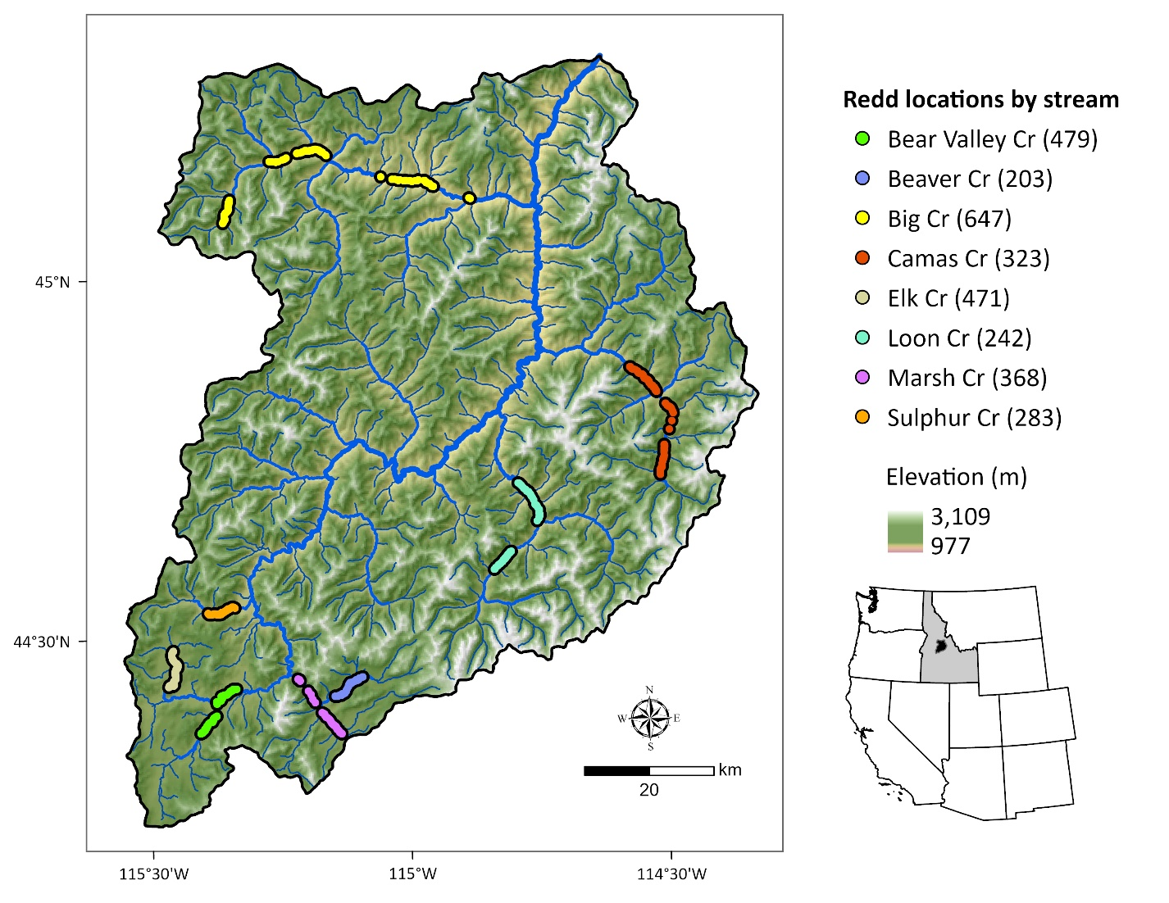Figure 1. Middle Fork Salmon River watershed illustrating major tributaries and locations of georeferenced Chinook Salmon redds from 2002 to 2005 (count of redds per stream given in parentheses). Point locations were dissolved for visualization.

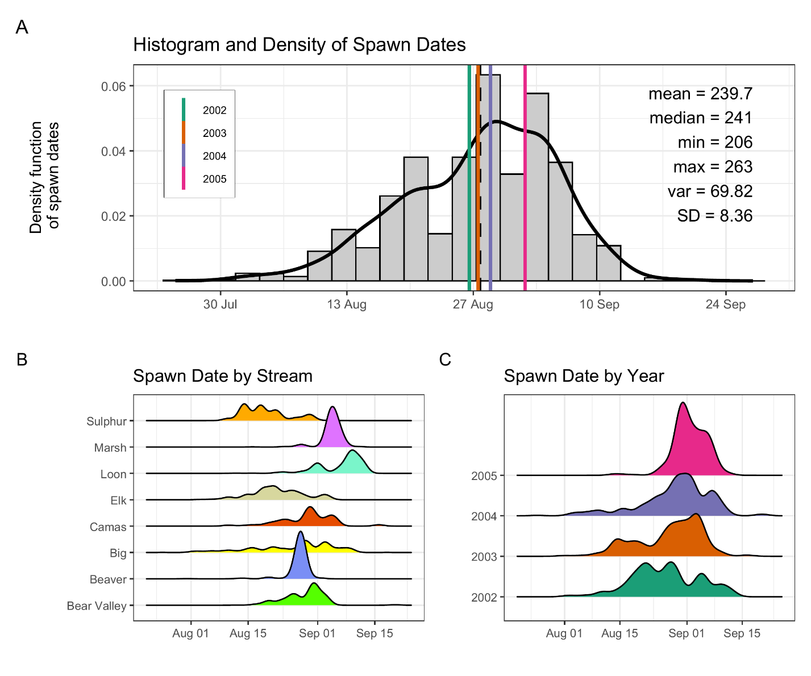
Figure 2: Histogram and density of Chinook salmon spawn timing across all streams and years (A), by stream (B), and by year (C). In panel (A), the histogram and kernel density illustrate the overall distribution of spawn dates; vertical-colored lines illustrate year-specific means, and the black line depicts the global mean. Spawn timing was generally unimodal, peaking in late August to early September.

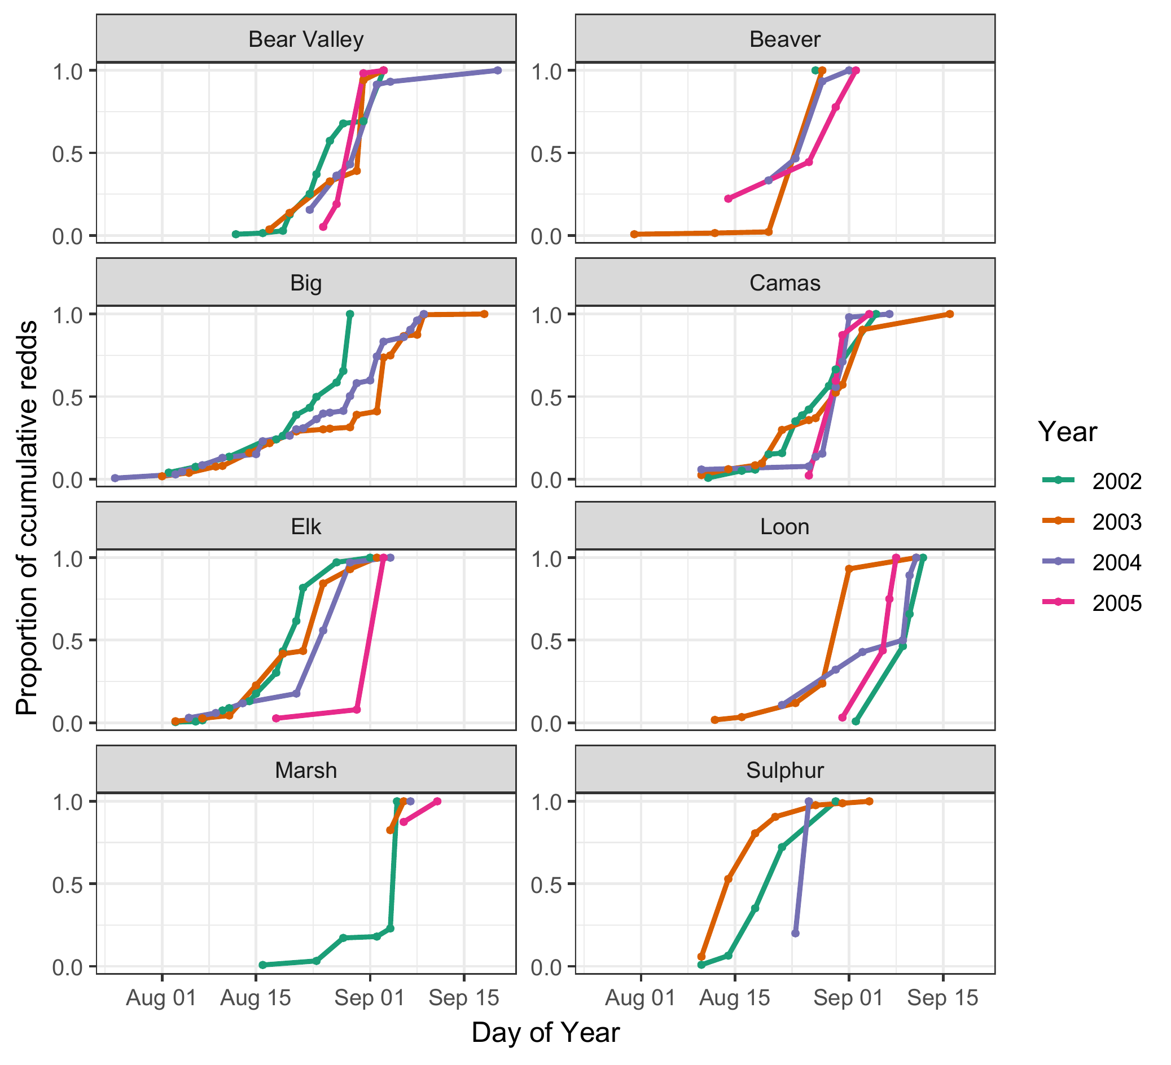
Figure 3. Proportion of cumulative Chinook salmon redds over time (day of year) across years (2002–2005) and streams. Each line represents a different year, denoted by color. Stream-specific panels illustrate temporal variation in the progression of spawning activity, as measured by cumulative redd counts normalized to the maximum value in each stream-year combination. From 2003-2005, only 2, 1, and 2 redd surveys, respectively, were completed in Marsh Creek.

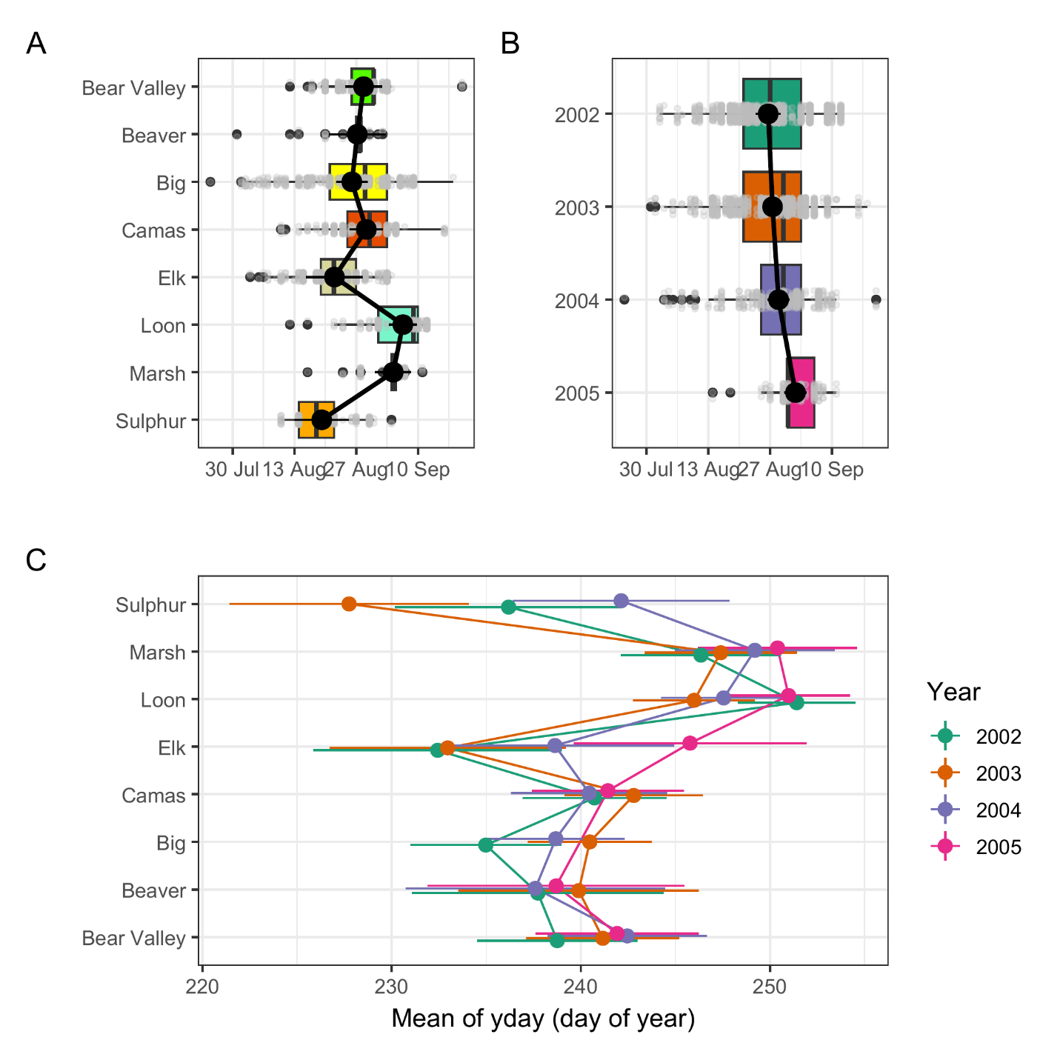
Figure 4. Predicted mean spawn dates by stream (A), year (B) and stream and year (C), from the final mixed-effects model. Black points with black lines (A, B), and colored points with horizontal lines (C) represent estimated marginal means and 95% confidence intervals. Boxplots in panels A and B illustrate the distribution of observed redd counts by group, with individual data points in grey. The modeled predictions represent marginal means accounting for fixed effects and averaged over random effects.
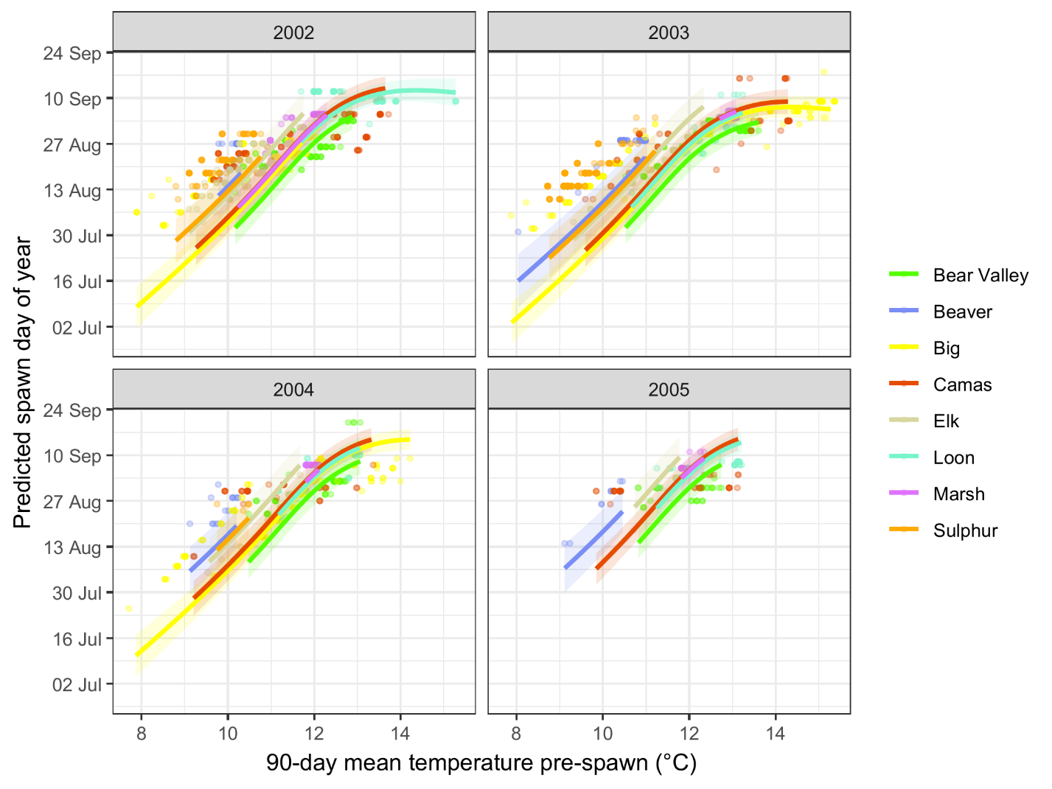
Figure 5. Predicted relationship between spawn timing and 90-day pre-spawn mean temperature by stream and year. Lines represent model predictions from the final mixed-effects model. Colored points illustrate observed spawn timing, shaded ribbons represent 95% confidence intervals for predictions.

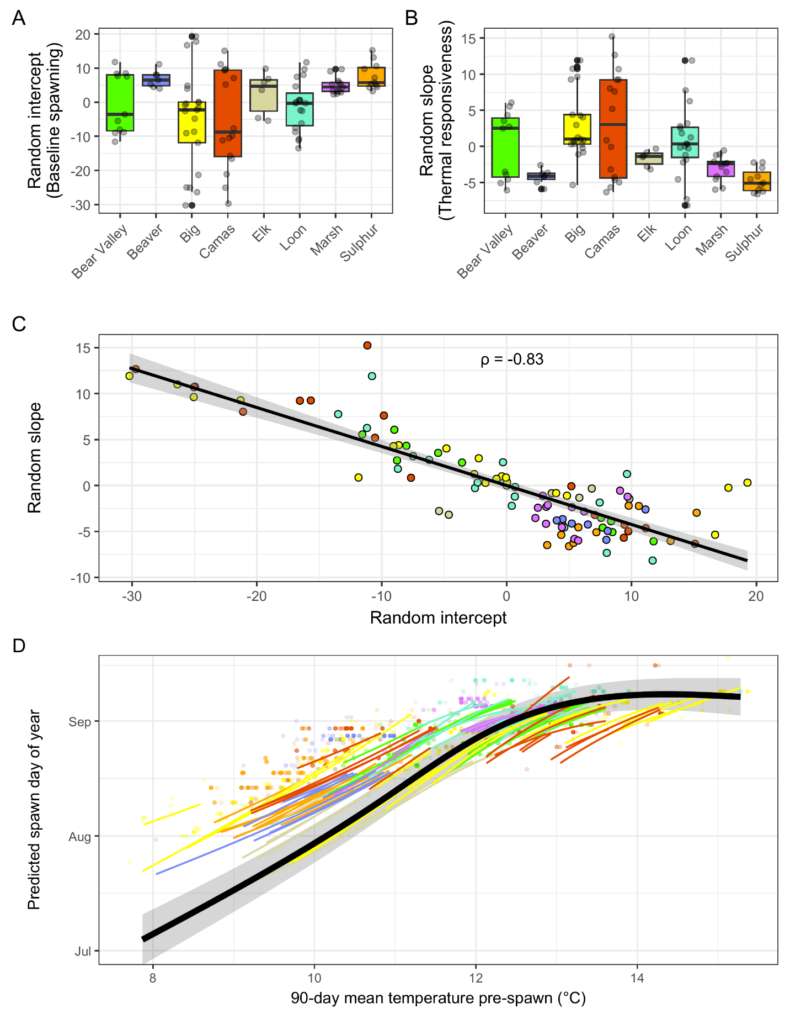
Figure 6: Reach-level (COMID) variation in random intercepts, random slopes, and predicted spawn timing relationships from the final mixed-effects model. (A) Boxplots of random intercepts by stream, representing reach-level deviations in baseline spawn timing after accounting for fixed effects (temperature, stream identity, and year); positive values indicate later-than-expected spawning, negative values indicate earlier-than-expected spawning. (B) Boxplots of random slopes by stream, representing reach-level deviations in thermal sensitivity (responsiveness of spawn timing to 90-day antecedent temperature); larger positive values indicate stronger temperature dependence. Points in A and B represent individual stream reaches (COMIDs). (C) Correlation between random intercepts and random slopes across all COMIDs, colored by stream. The strong negative relationship (ρ = −0.83) indicates that reaches with earlier baseline spawn timing exhibit greater thermal sensitivity. The line represents a linear fit with 95% confidence interval. (D) Predicted temperature–spawn timing relationships for individual COMIDs (colored lines, colored by stream) and the population mean response (black line with 95% confidence interval).

